Azure Data Factory Capstone - Covid Use Case

**- Name: Induja D(2319849)**

**Cohort code:CSDAIA24AZ003**

**Introduction:**



The "Azure Data Factory Capstone - Covid Use Case" project was completed in compliance with business requirements using a variety of tools, including Synapse, Azure Data Factory, and Azure Data Lake Storage. These Azure components facilitate the process of removing data from its source (Data Lake), transforming it to meet business requirements, and then loading it into a destination data warehouse. The "Azure Data Factory Capstone - Covid Use Case" system was developed to teach users how to use Azure cloud data services to build a practical data pipeline in Azure Data Factory (ADF) for the purpose of analyzing the covid trend across the regions. This case study will teach us anything.   
 1. How to use Azure Data Factory (ADF) to ingest data from flat files into Azure Data Lake Gen2 and Azure Synapse.

2.How to transform data using Data Flows in Azure Data Factory (ADF).

**Objective:**

This project's main goal is to give us hands-on experience with storage, ADF pipelines, mapping data flows, and Azure Synapse. It also aims to teach us how to use Azure Data Factory (ADF) to ingest data from flat files into Azure Data Lake Gen2 and Azure Synapse, as well as how to transform data using Data Flows in Azure Data Factory (ADF) and load it into Azure data lakes. This report provides an overview of the entire project, enabling us to comprehend and analyze the Azure use case scenario and its applications..

**Overview of Data Factory Flow:**

Consumes



**Activity**

**Data Set**

Produces

Is a logical Grouping Of

Runs On

Represents a data item stored in

# Pipeline

**Linked Service**

**Project Requirements:**

**Requirement 1:** Ingest raw ﬂat ﬁles from data lake to synapse (data warehouse)

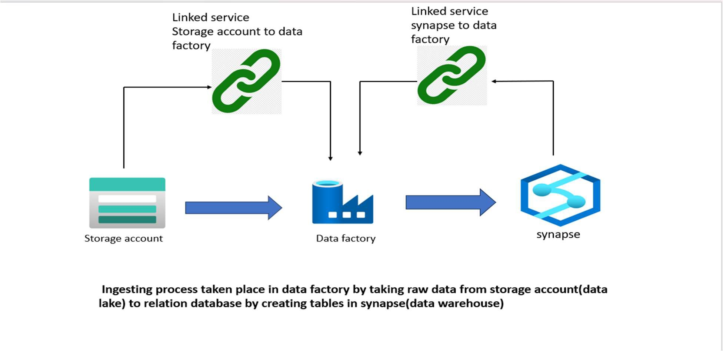

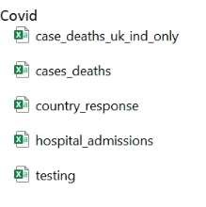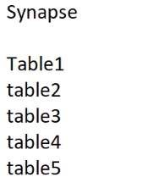

**Azure Data Factory**

**Lookup Foreach Copy**

**SQL database**

Table 1

Table 2

Table 3

Table 4

Table 5

**Azure Synapse**

**Azure Data Lake Storage**

**Requirement 2:** Transform data using Data Flows in Azure Data Factory (ADF)

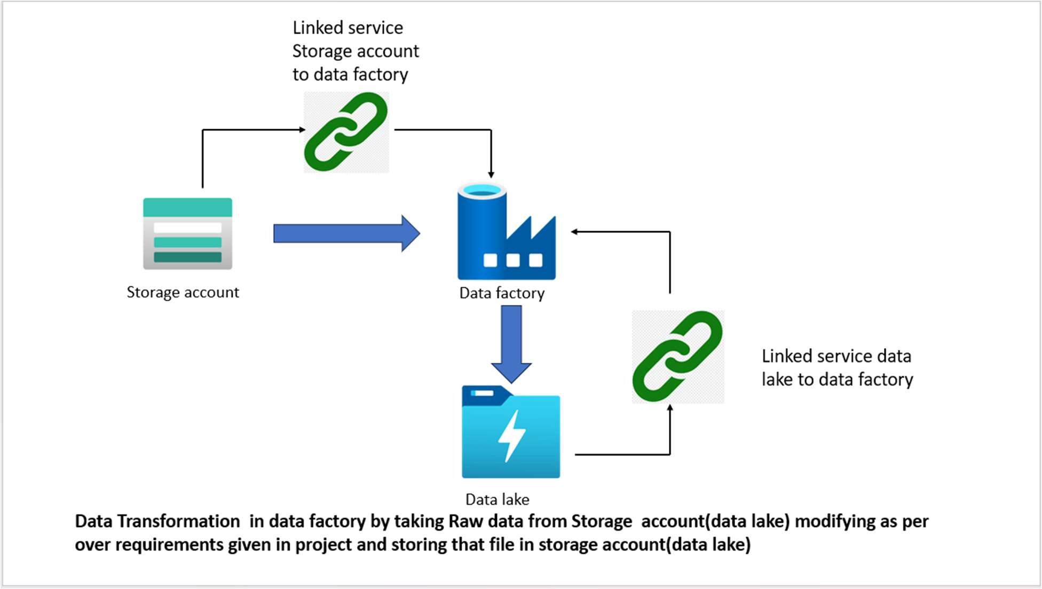



**Azure Data Flow**

**Find The Continents Which Have Maximum Daily Death by using dataﬂow.**

**transformPath**

covid_analysis.csv

**Azure Data Lake Storage**

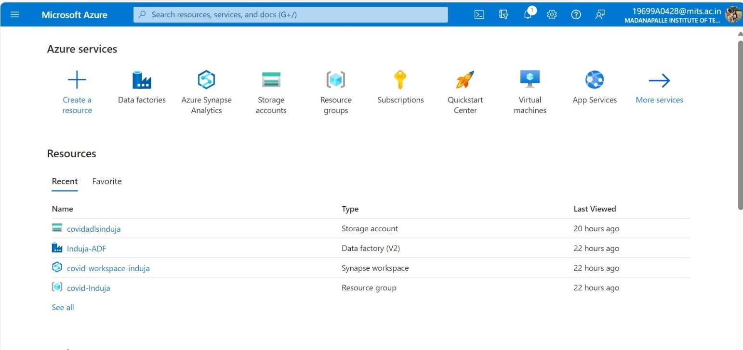

**Step 1:** Created one Resource group(**covid-Induja**) and required resources for project like Storage account(**covidadlsinduja**), Synapse workspace (data warehouse) (**covid-workspace-induja**), Azure Data factory(**Induja-ADF**)



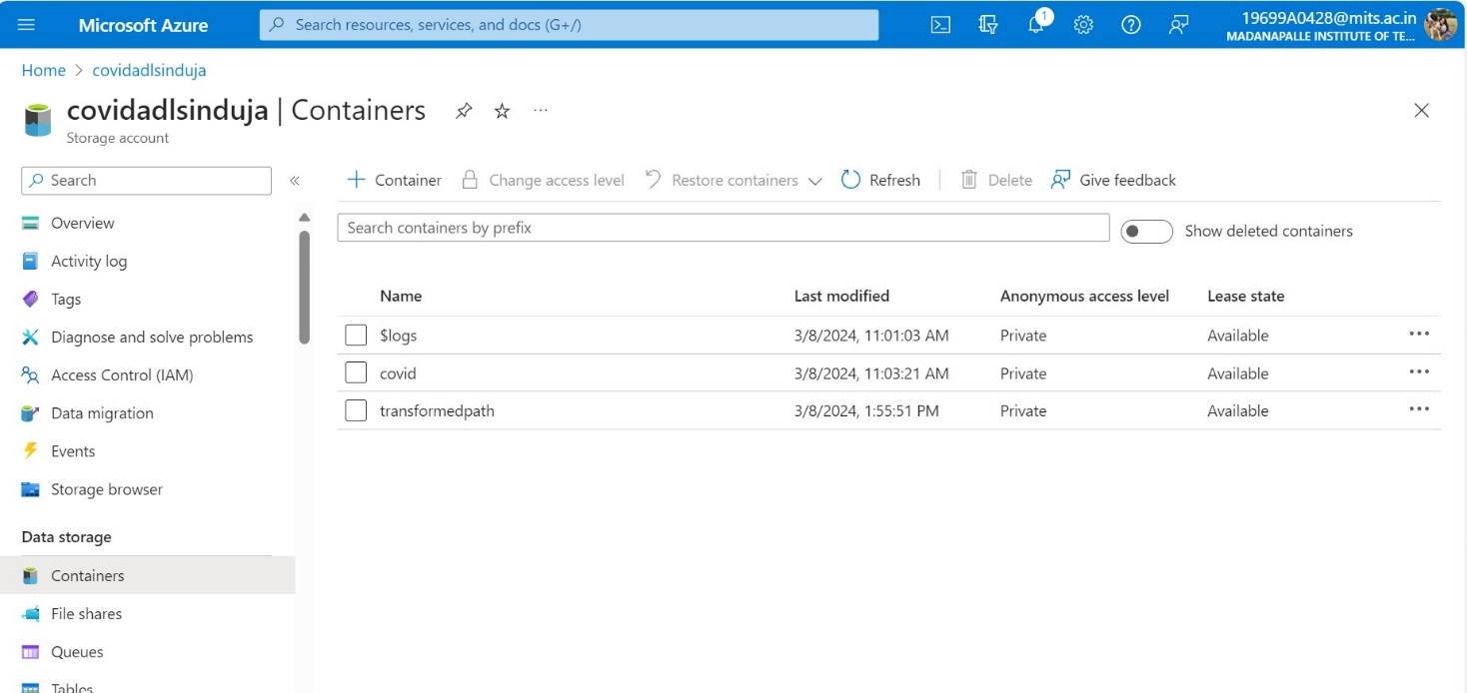

**Step 2:** Created Container with name “**covid**” in Storage account (data lake) for holding folder which contains ﬂat ﬁles.

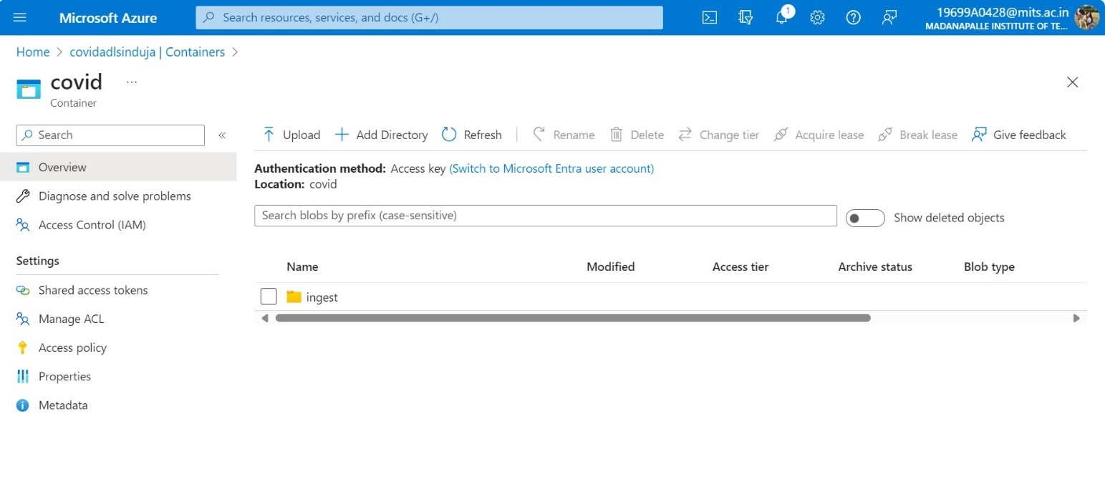

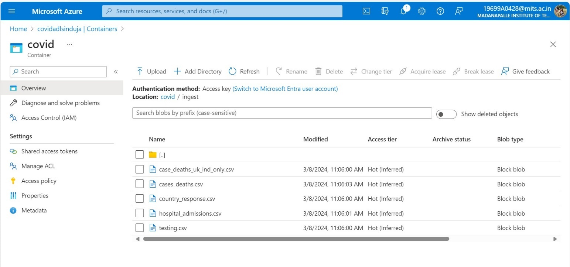

**Step 3:** Create Folder with name “**ingest**” inside the Container “covid” and uploaded csv ﬁles (data sets) form personal computer which are there in zip ﬁle given in project document.

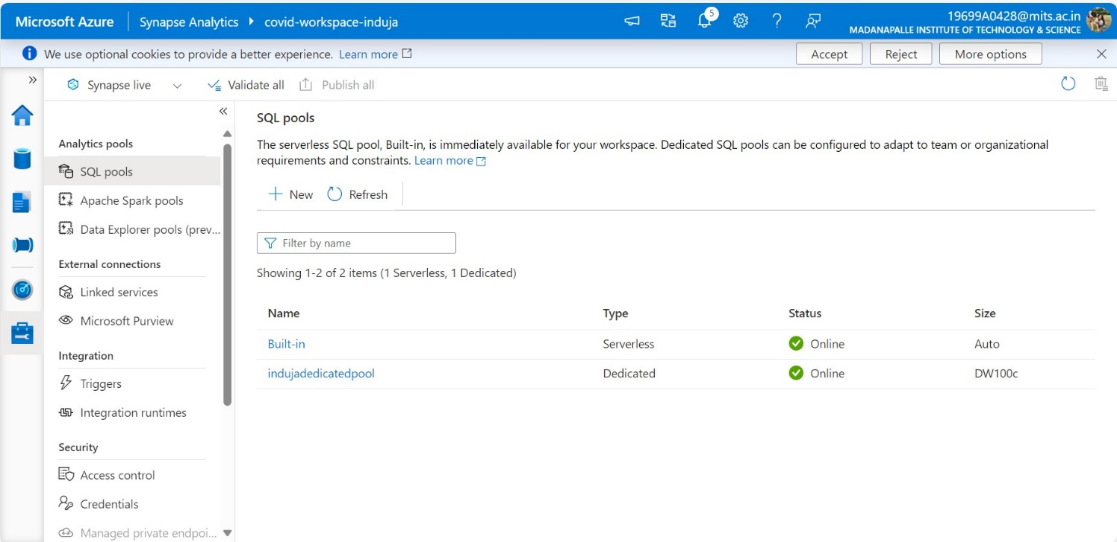



**Step 4:** Create **Azure synapse resource** and one **dedicated pool** inside the azure synapse for data warehouse creation and it should be turn on.

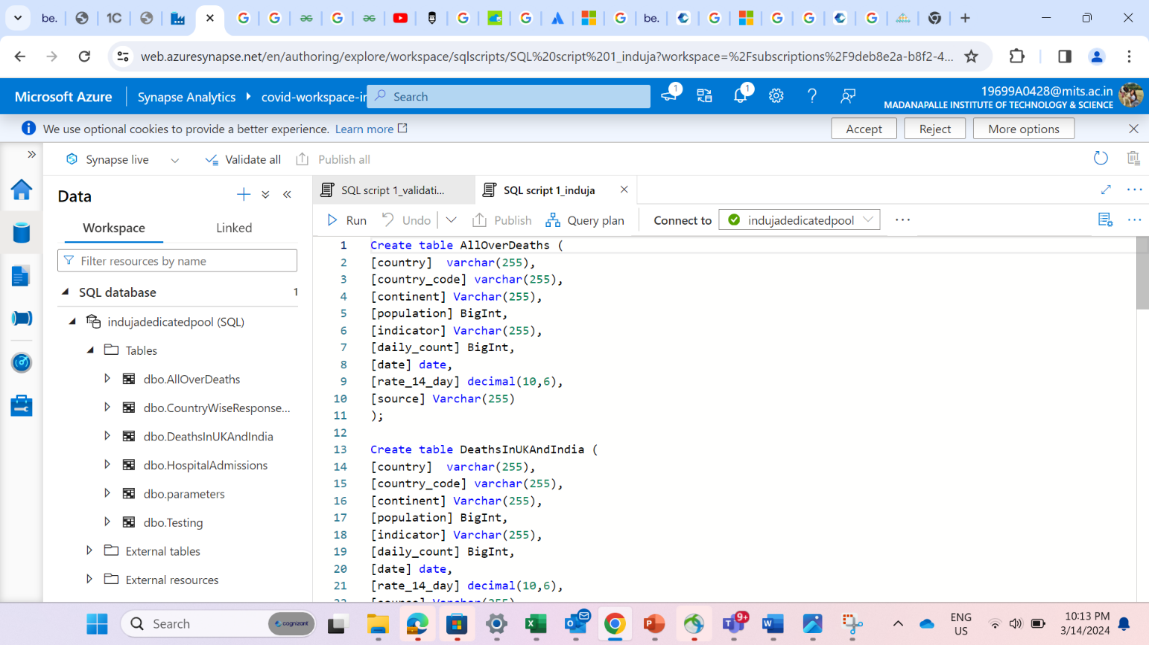

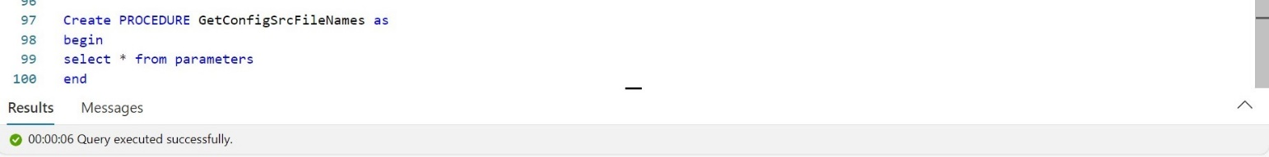

**Step 5:** Creating **two linked services** as per the project requirement in Azure data factory.

* **Storage account (data lake) to Azure data factory.**
* **Azure synapse workspace to Azure Data factory**.

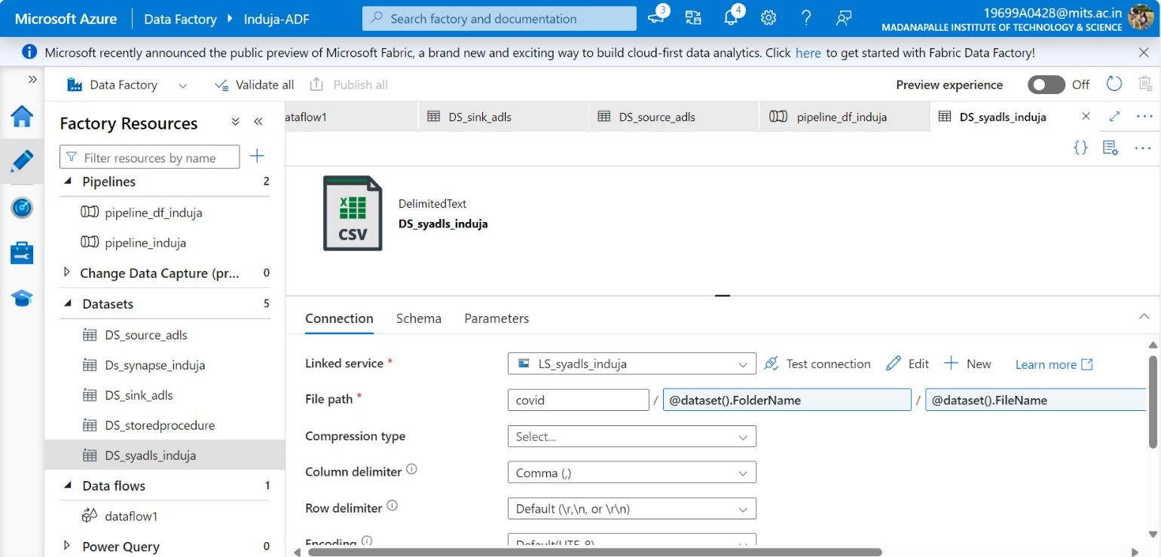

**Step 6:** Created **dataset (DS_syadls_induja)** for fetching ﬂat ﬁles from storage account (data lake) which are present in ingest folder inside covid container.

**Step 7:** Created requried **SQL Tables** in synapse SQL database by writing create table queries in Synapse workspace (SQL Script).



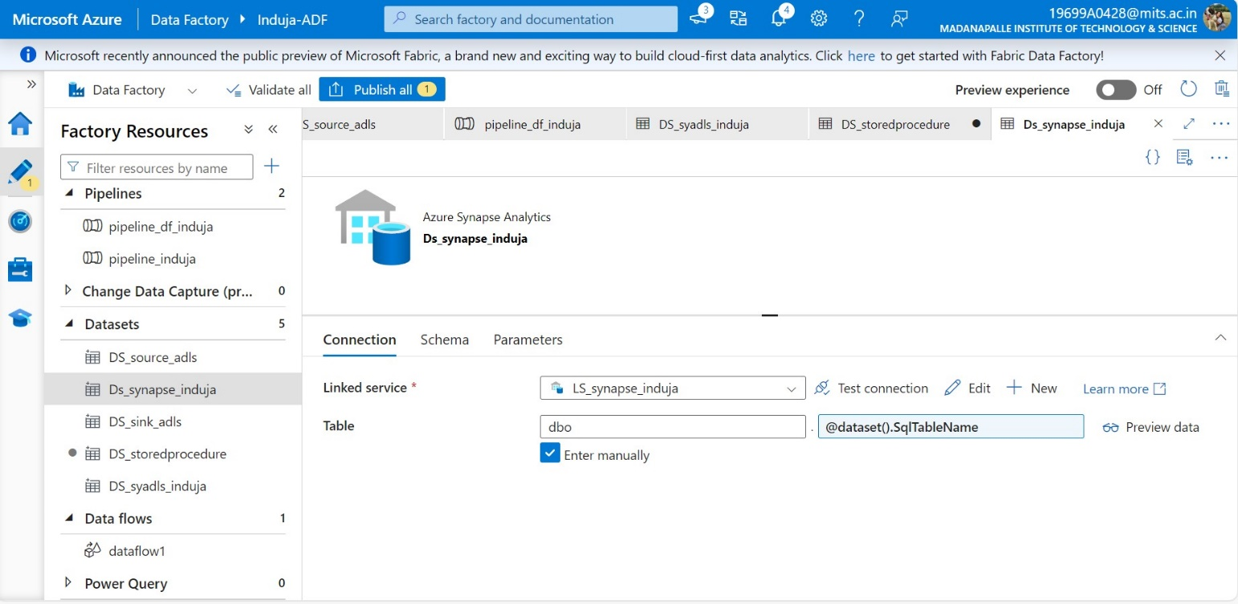

**Step 8:** Created **dataset (Ds_synapse_induja)** for inserting into SQL Tables created in synapse (data warehouse).



**Step 9:** Created **stored procedure(sp_GetConﬁgSrcFileNames)** for fetching records from parameters table.

**Step 10:** Created **dataset(DS_storedprocedure)** for fetching parameters table form synapse(data warehouse).

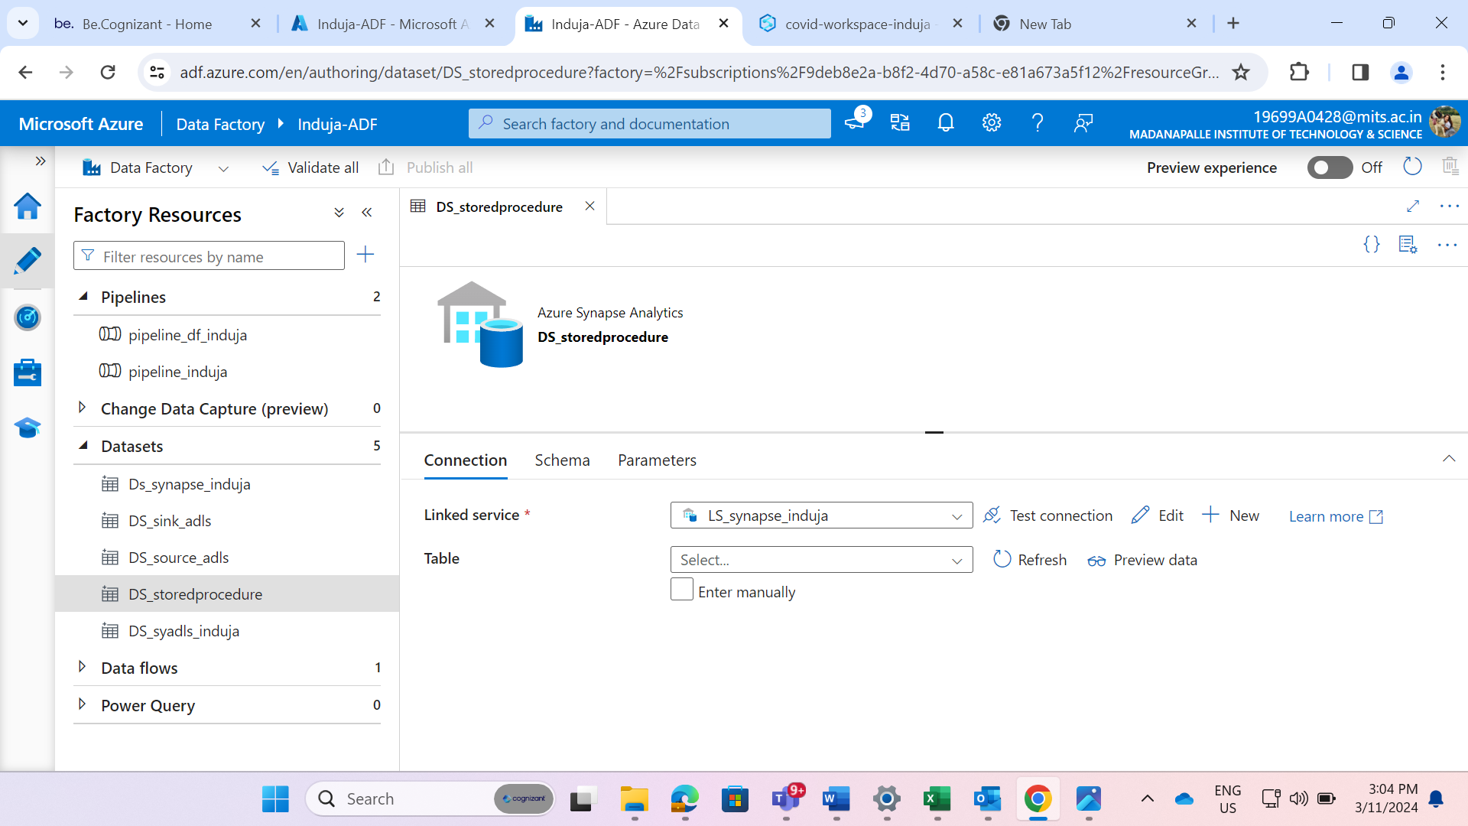



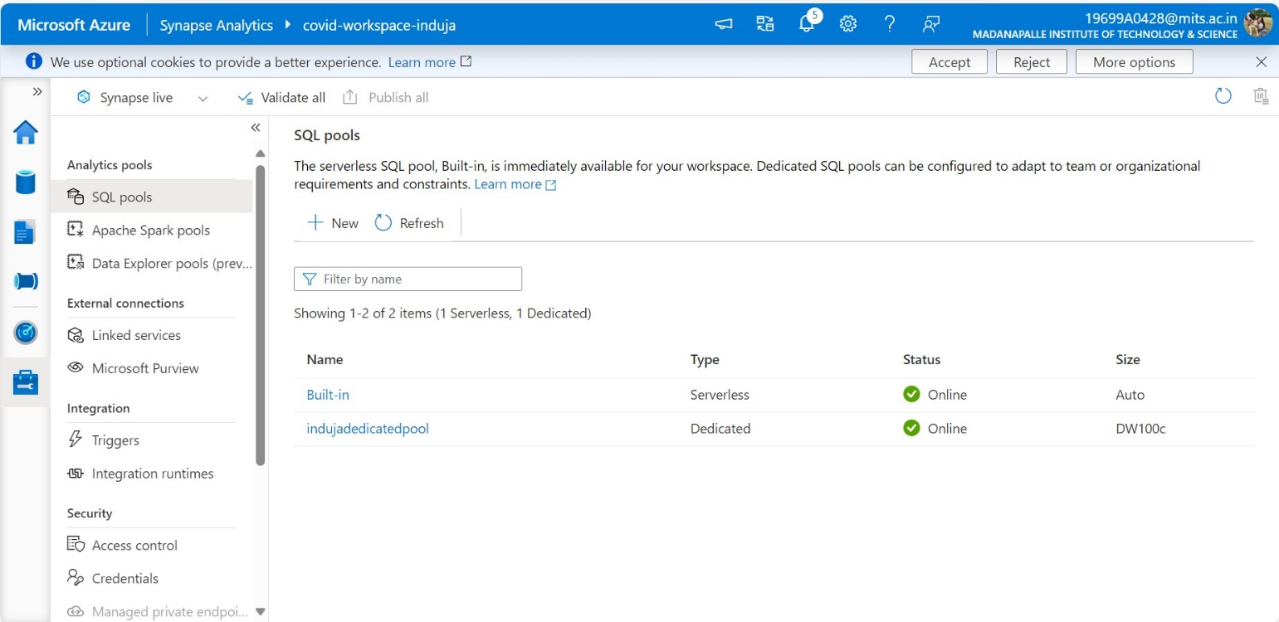

**Step 12:** Before creating pipeline in data factory, we need **to turn on the dedicated pool**. we need to check these two to three times while moving on to creation of pipeline.

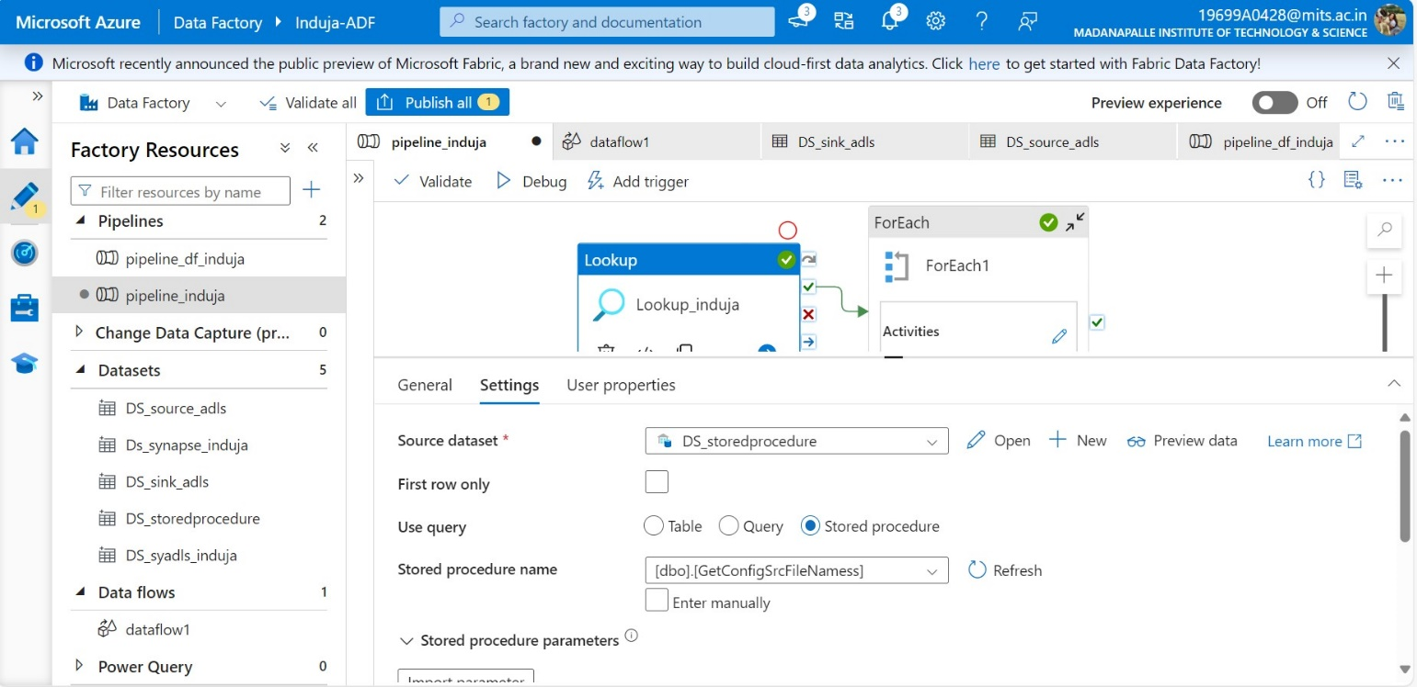



**Step 13:** Create a **pipeline** (**Pipeline_induja**) and Drag and Drop the **Look up Activity** into pipeline workspace and set the **source dataset (DS_storedprocedure)** for Lookup and choose the option **stored procedure** and given the stored procedure name created in synapse (data warehouse).

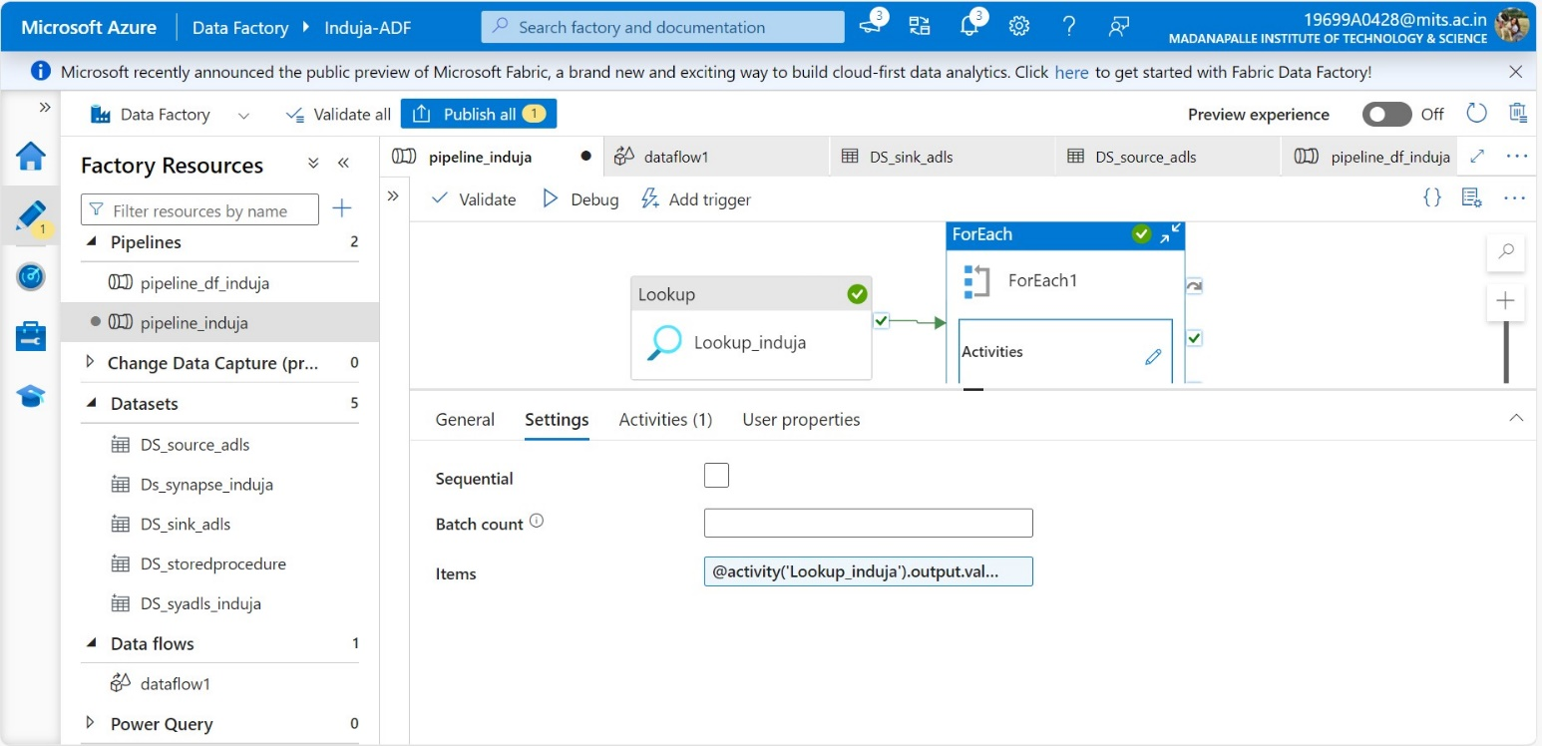



**Step 14:** Drag and Drop **For each activity** in pipeline workspace and conﬁgure the for each activity settings like **Items** with output of look up activity **(@activity(‘Lookup1’). Output. Value).**

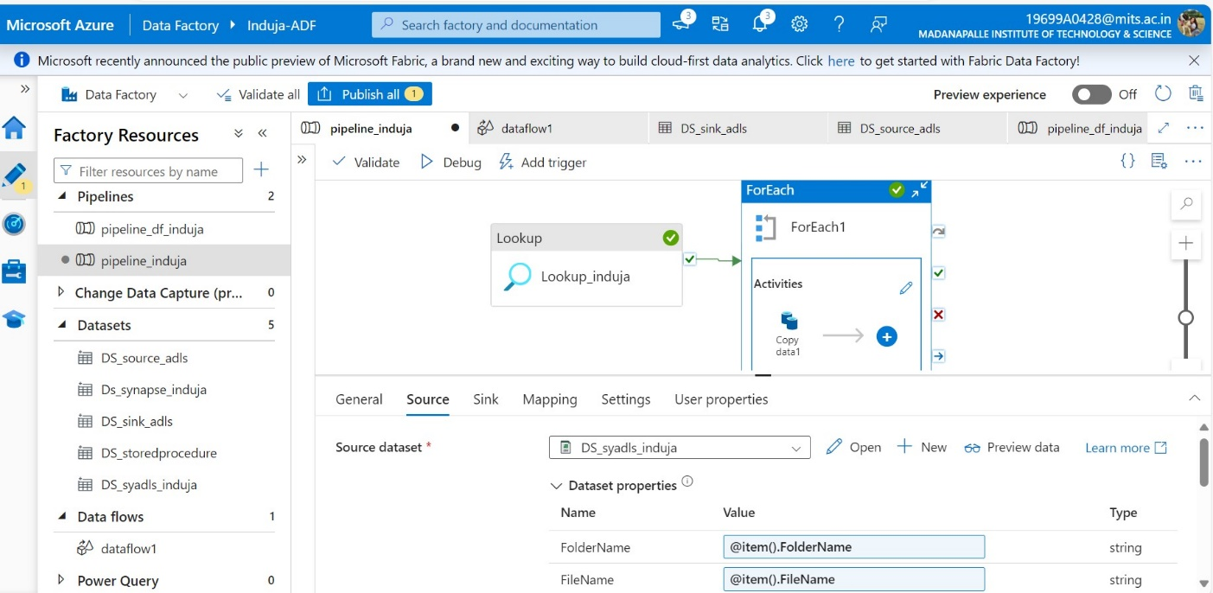

**Step 15:** Click on add activity symbol present on foreach activity and inside foreach activity add a **Copy activity** for copy data from CVS ﬁle into SQL table.

Conﬁgure settings at source side in copy activity by giving dataset **(DS_syadls_induja)** and giving folder name and ﬁle name dynamic by taking from foreach activity by **item.**

Folder Name **(@ {item (). FolderName}),** File Name **(@ {item (). FileName})**



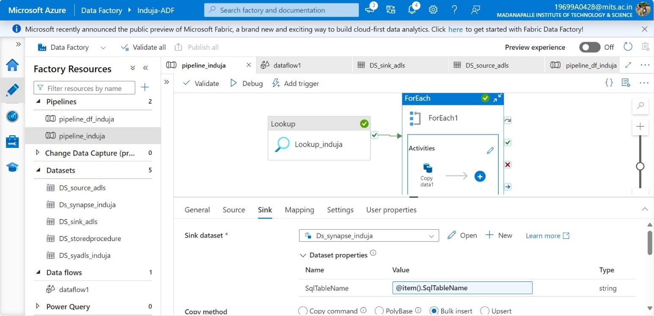

**Step 16:** Conﬁgure setting in copy activity at sink side by giving dataset **(DS_synapse_induja)** and giving sqltableName dynamically by taking from foreach activity by item→sqltableName **(@ {item (). sqltableName})**

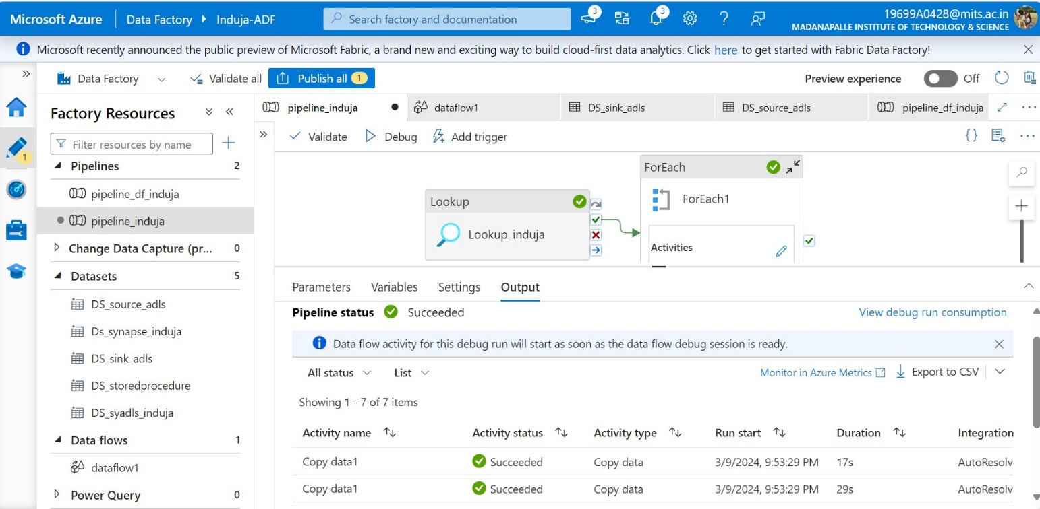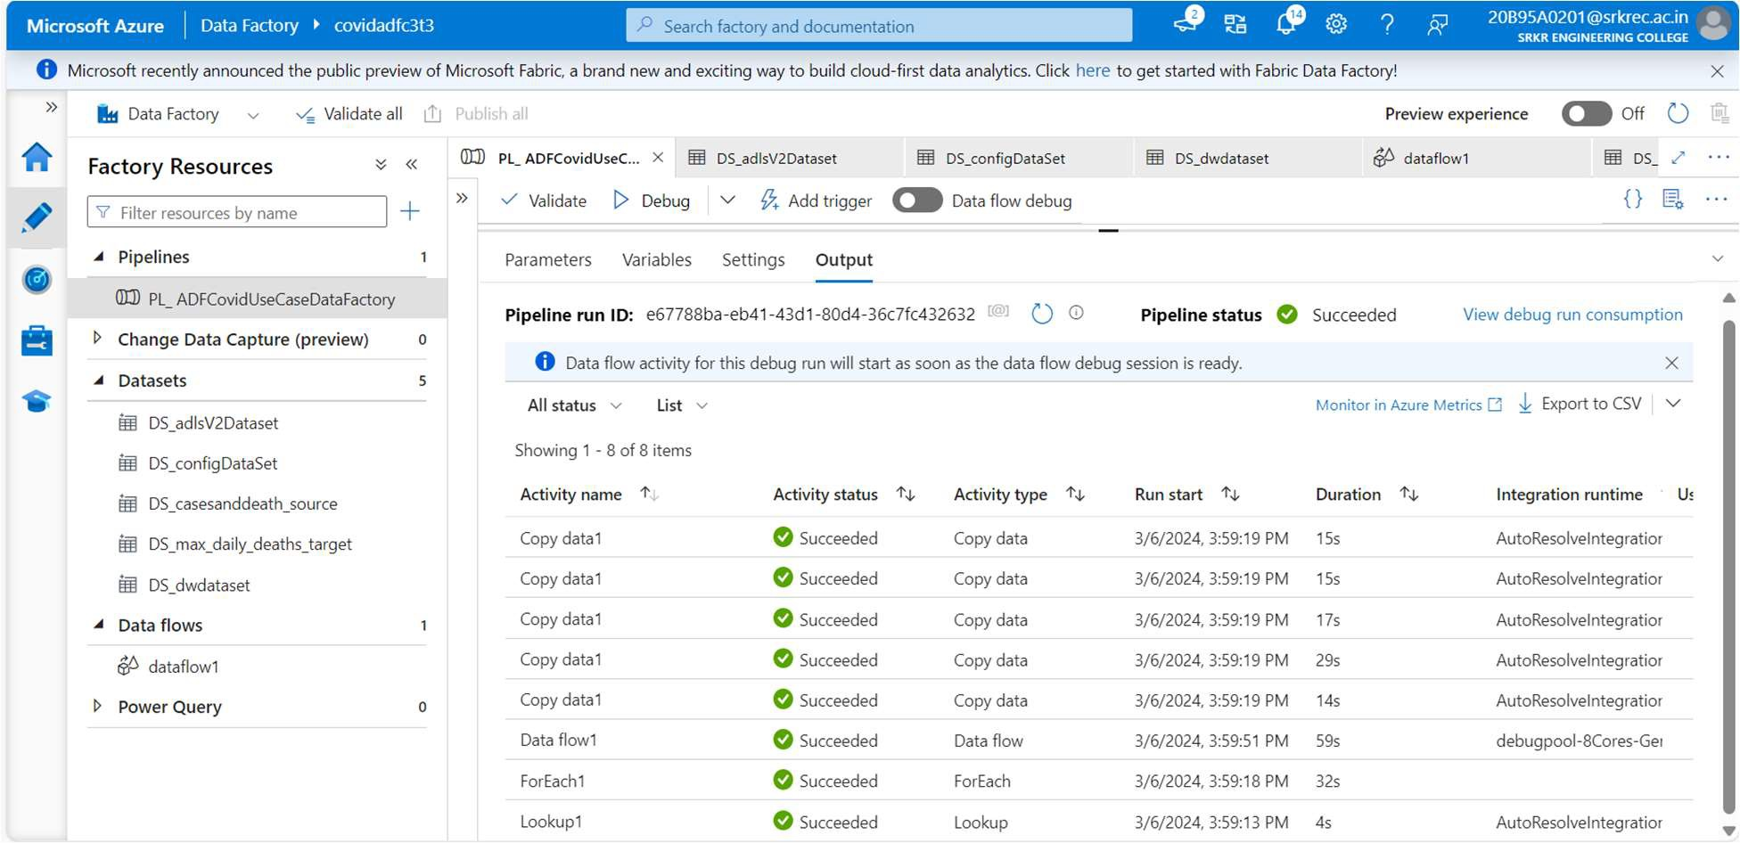

**Step 17:** After setting whole pipeline by using Lookup and Foreach activity recheck all parameters given in each conﬁguration setting, check the dedicated pool is turn on and then turn on the debug option in pipeline. Finally, all the activities are successfuly completed.

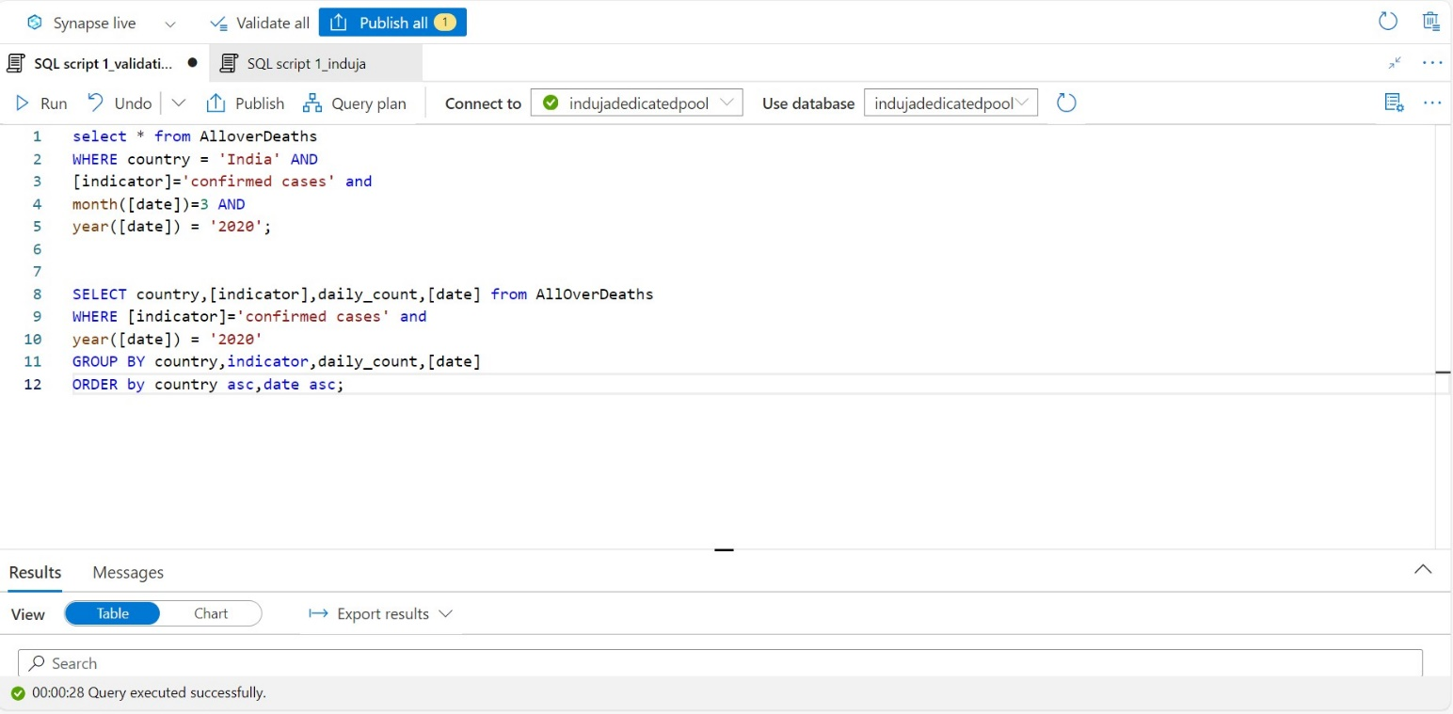

**Step 18:** After successfully run of pipeline now we need check the data inserted into tables in data warehouse by preforming two SQL queries operation given in project documentation.

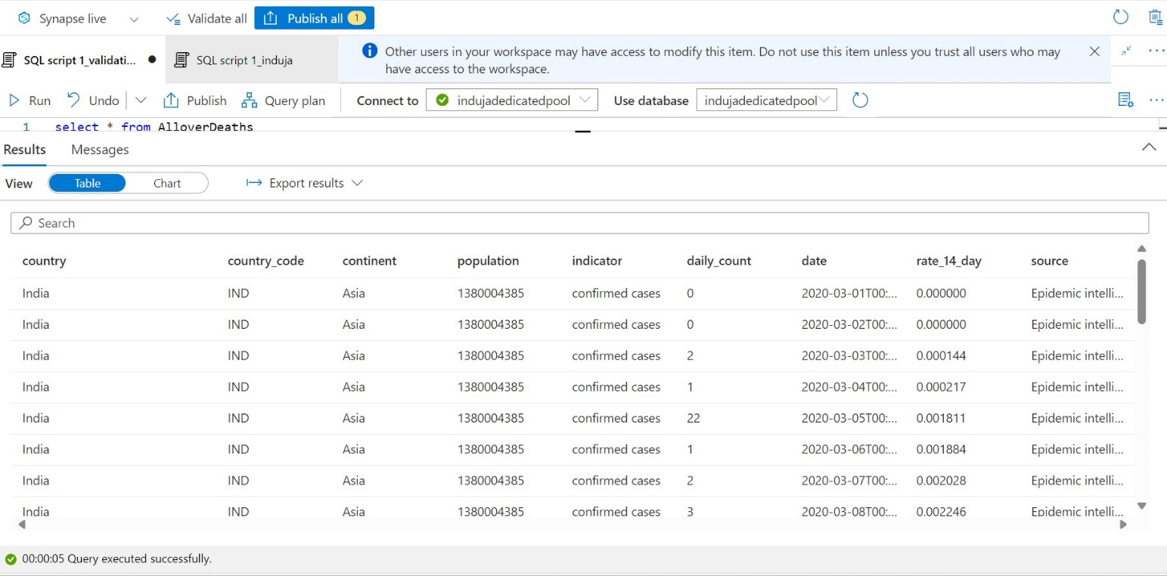



**Step 19:** After running ﬁrst and second SQL Query written in SQL script and it is successfully completed and given output as per the query.

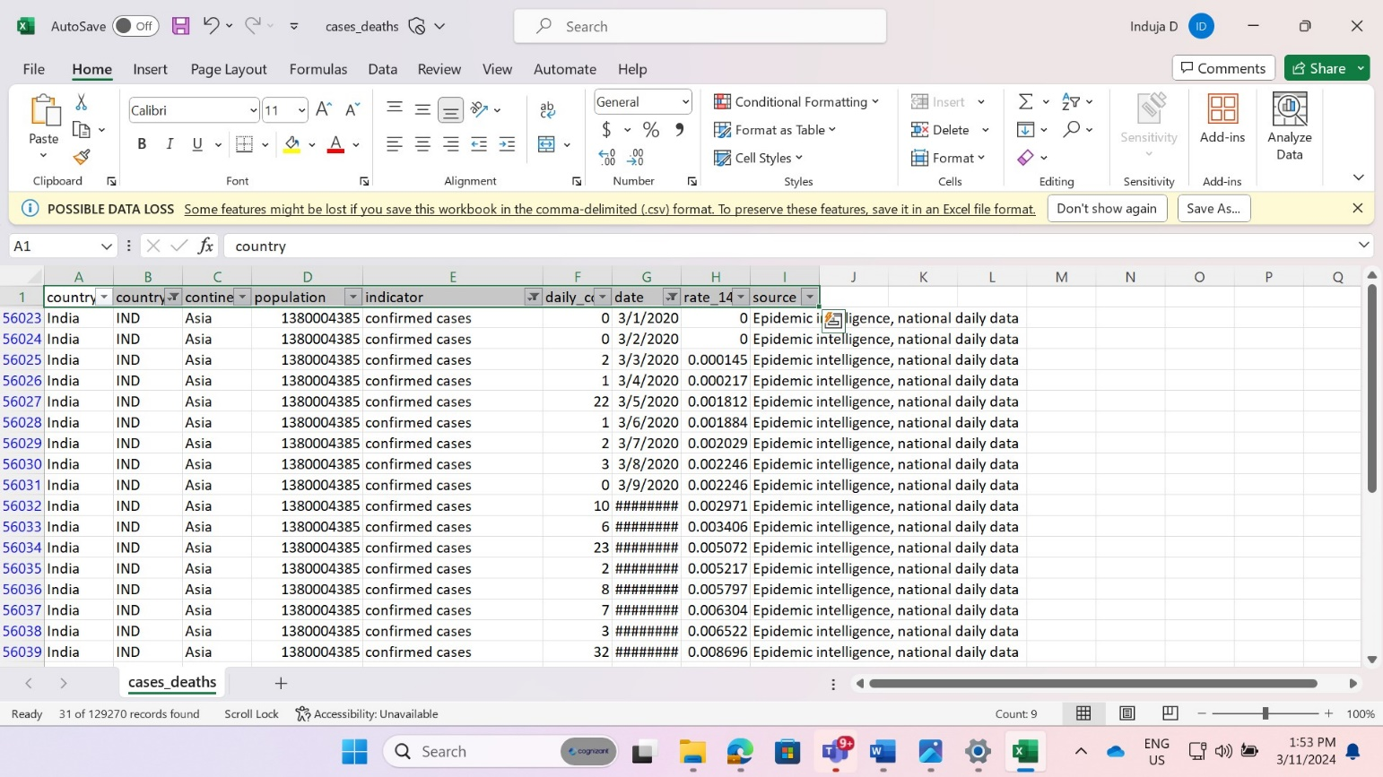

**Step 20:** compare the output appear for previous SQL query written in SQL script with original CSV ﬁle in excel sheet.

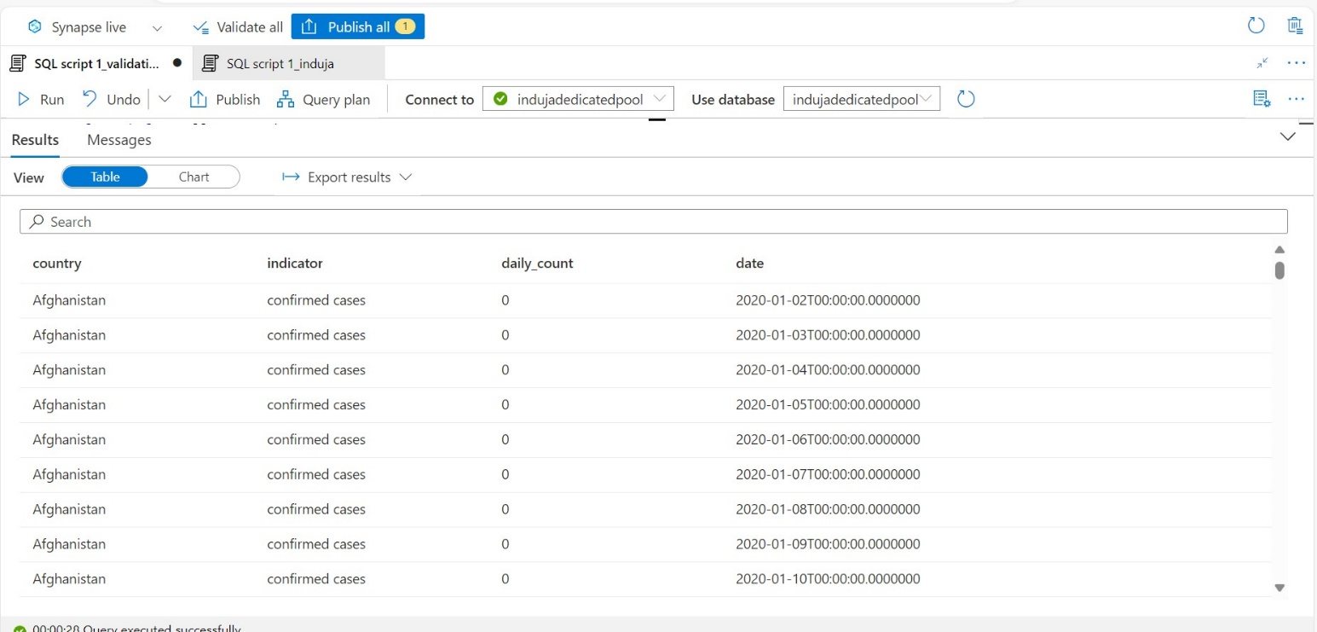

**Step 22:** Successfully query is done and given output as per the query.

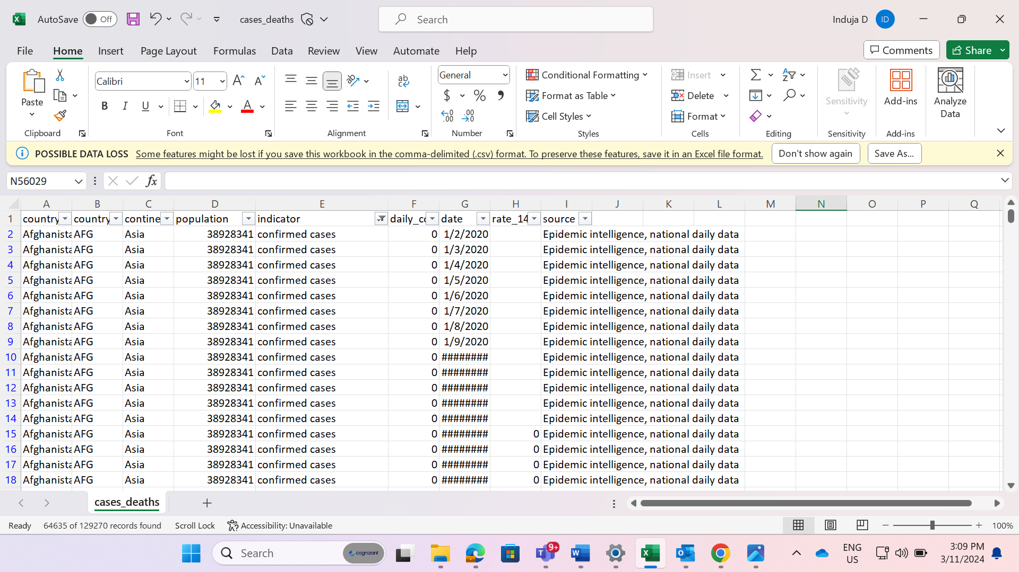

**Step 23:** Compare the above SQL query output with data which is appear from CSV ﬁle which is open in excel for reference check.

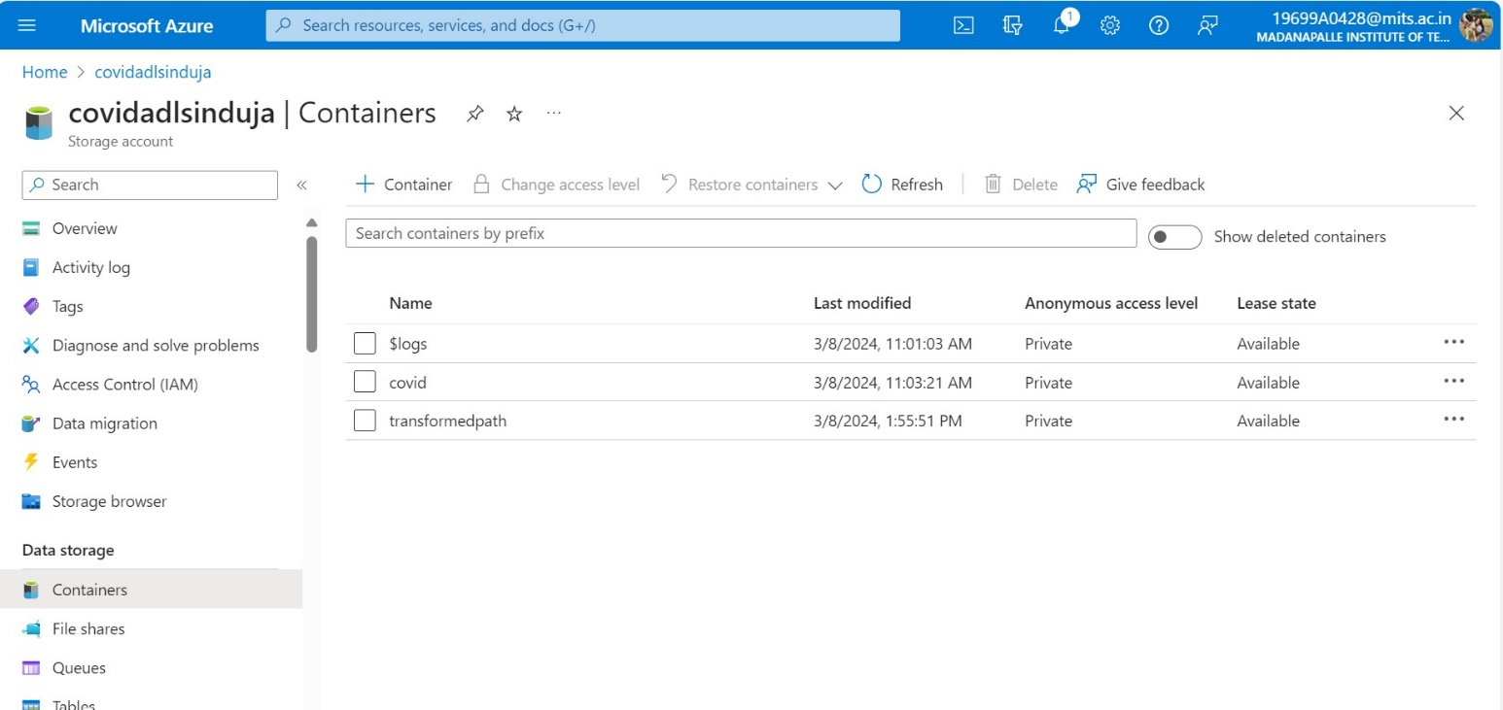



**Step 24:** Create another container with name **“transformedpath”** for second requirement given in project for storing transformed data ﬁle by using data ﬂow.

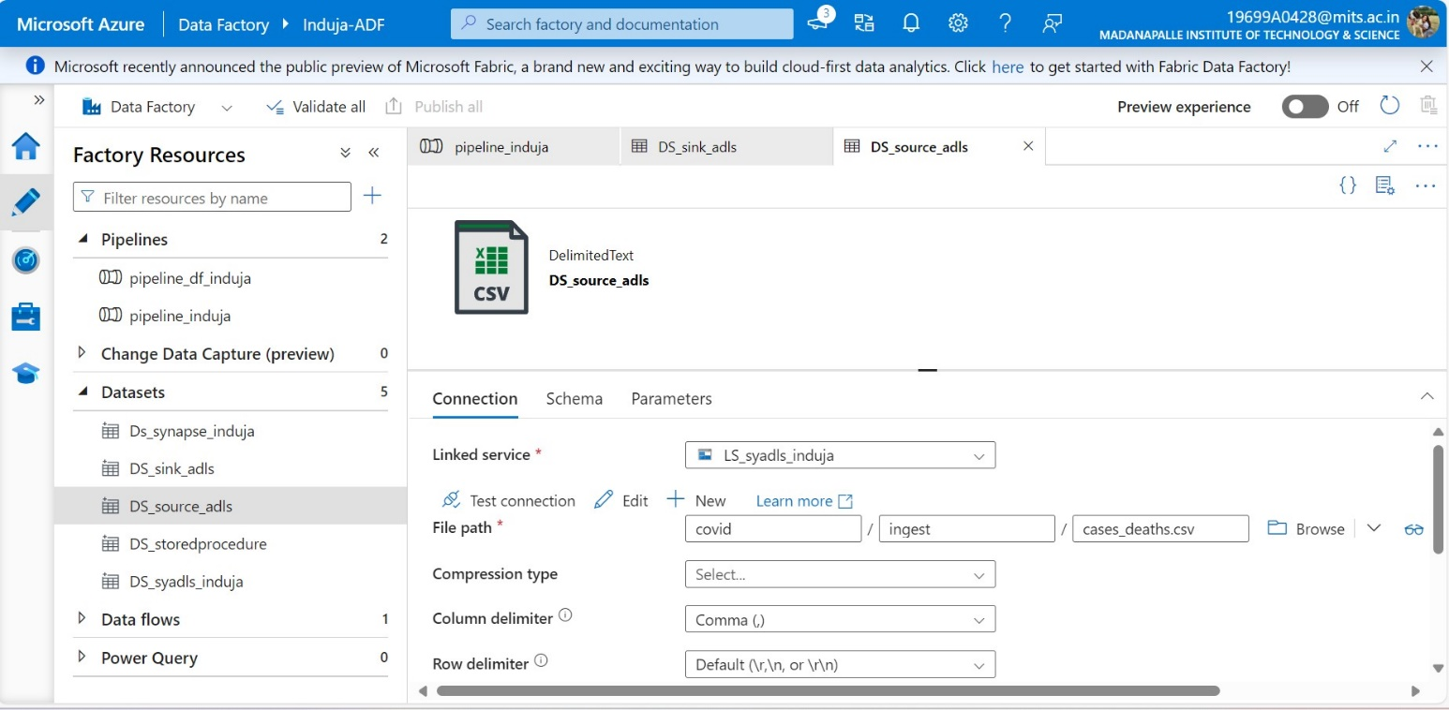





**Step 25:** Create source dataset (**DS_source_adls**) for dataﬂow by giving a ﬁle speciﬁc ﬁlename on which data transformation need to be taken place as per project requirement.

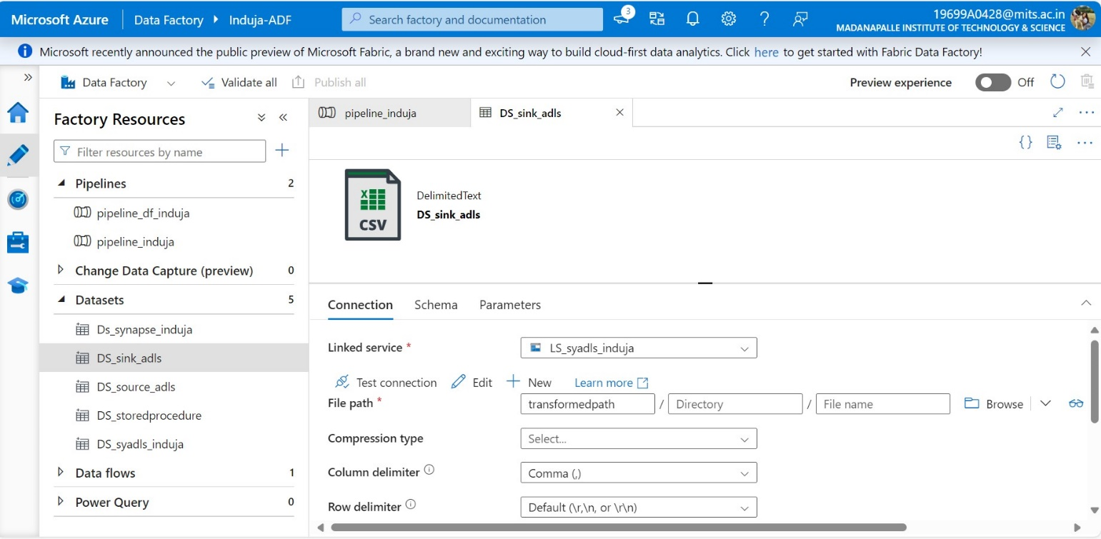

**Step 26:** Create target dataset (**DS_sink_adls**) for dataﬂow to keep that data transformpath ﬁle in speciﬁc place for further use.



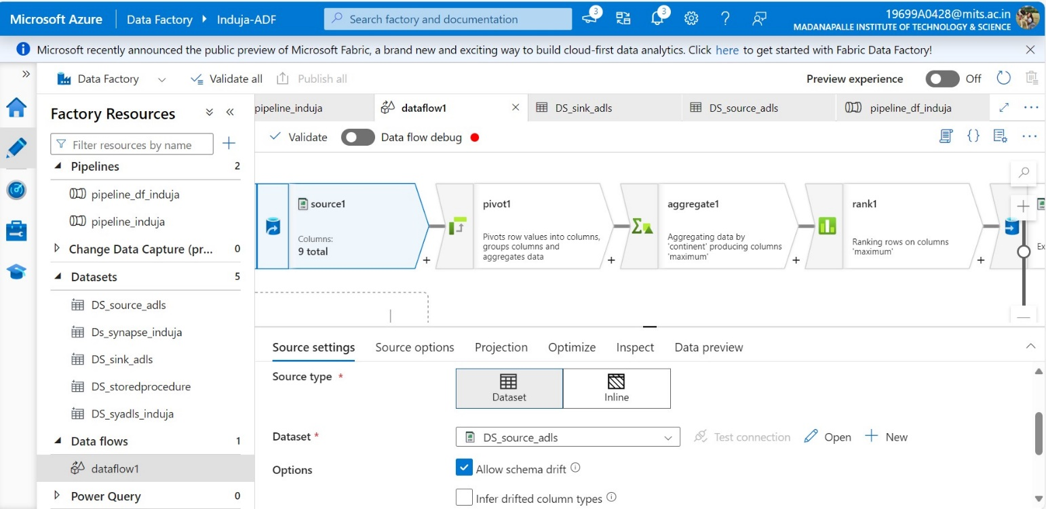

**Step 27:** Develop dataﬂow by using some transformations like source, ﬁlter, pivot, aggregate, rank and sink as per the question given in project documentation.



**Step 28:** After successfully creating dataﬂow, I click on dataﬂow debug output appear as per the question.



**Step 29:** Drag and drop the data ﬂow into the pipeline workspace and connect with before activity to run after successfully complication of before activity.

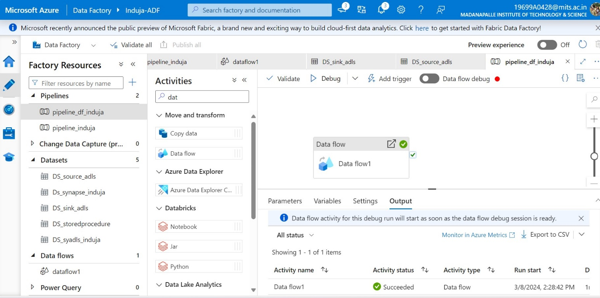

**Step 30:** Dataﬂow is completed successfully after click on debug as how in above picture.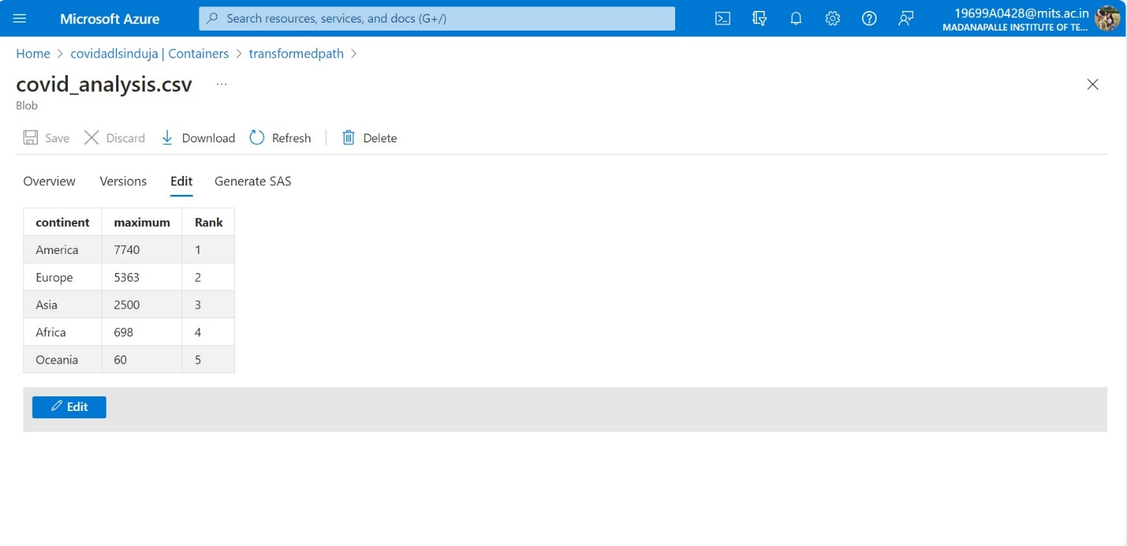

**Step31:** After that we need to check ﬁle is appear in the transformation container in storage account (data lake). I successfully got that ﬁle in my container as per the question given in the project documentation.

# CONCLUSION:



**Requirement 1 Output:**









**Requirement 2 Output:**

